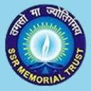
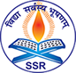
Swargheeya Sanjibhai Rupjibhai Memorial Trust,
SSR COLLEGE OF EDUCATION
Sayli, Silvassa – 396230, UT of DNH
(Accredited by NAAC B+ )
Mo: 9081160004, www.ssreducollege.edu.in

****************************************************************************************
Academic Year 2024-25
REPORT
Activity:- GMC/Student council election Batch 2024-26
Date:- 23/10/2024 (Wednesday)
In-charge:- Mrs. Nilima Kamlu
“Leadership is not about being in-charge. It’s about taking care of those in your charge.”

The Student Council serves as the voice of the student body, facilitating the sharing of ideas, interests, and concerns within the college community.

Objective : To provide an opportunity to participate in decision making process and enhance their holistic development.

The Student Council Election was held at SSR College of Education on 23rd October 2024. Preliminary students interested in standing for elections were invited to submit their nominations for various positions up 22nd oct 2024. Around 32 candidates were nominated for
9 different posts.
For this election Dr.Vinu Agrawal and Dr.Bhagirath Pande were worked as election counting officer. Previous year GMC members spoke about responsibilities of each post. Then candidates for various positions presented their manifestos in speeches to persuade students to vote for them.
This electoral process provided students with the opportunity to witness and exercise their fundamental right to vote. The polling process was democratic and anonymous, with students exercising their franchise by selecting their preferred candidates through an offline voting system.
Following the voting process, the eagerly awaited results of the SSR College of Education , batch 2024-26 Student Council Election were declared ,followed by oath ceremony of newly elected council member . Oath is given by Previous year(Batch 2023-25) GS Ms.Komal Mehta.
IQAC co-ordinator Dr.Sarika Patel gave the positive feedback on election process and Principal Dr.Meena Kute provided the motivation and best wishes to newly elected student council.
The student council election was successfully co-ordinated by Mrs.Nilima Kamlu.The college administration and student council will work together for betterment of college.

Co-ordinator Principal
Mrs.Nilima Kamlu Dr.Meena Kute

STUDENT COUNCIL /GMC : BATCH 2024-26
Sr. No. | Post | Student Representative
1 | President/General secretory | Siddhi Gupta
2 | Treasurer | Juhi Ranjan
3 | Discipline Secretory | Komal Dubey
4 | Cultural Secretory | Sheetal Vyas
5 | Sport Secretory | Sharda singh
6 | Teaching Secretory | Rajashree Dongarkar
7 | Excursion Secretory | Dikshali Patel
8 | Magazine/Newsletter Secretory | Shruti Tokre
9 | Library Secretory | Swati Kumari
S

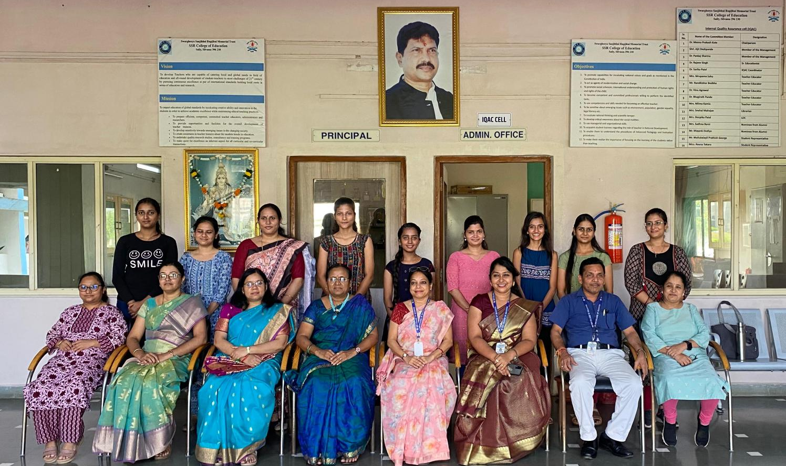

Glimpses of GMC election (23/10/2024)
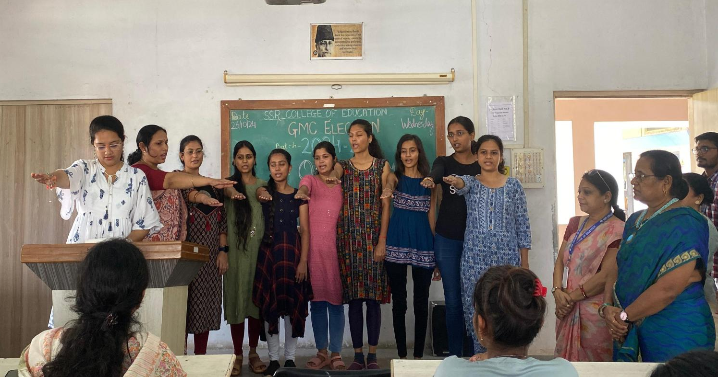

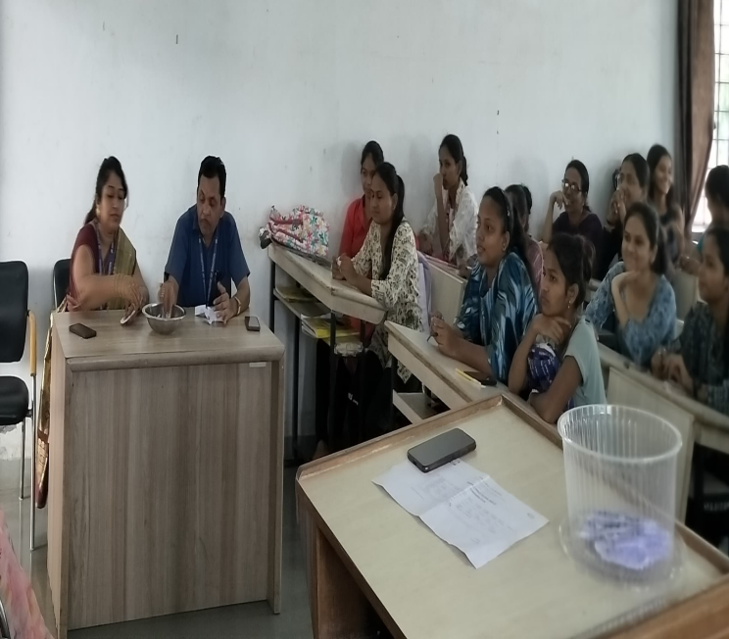
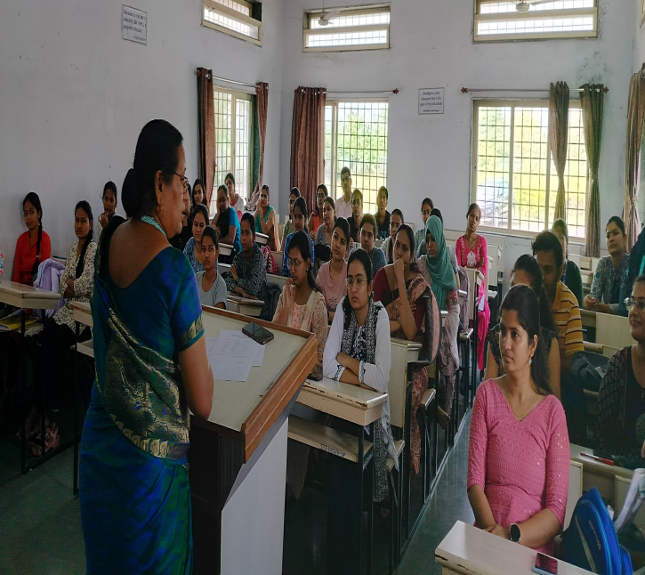
O

