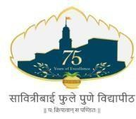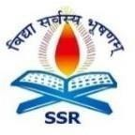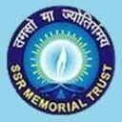

Swargheeya Sanjibhai Rupjibhai Memorial Trust’s
SSR College of Education
Saily, Silvassa U.T. of Dadra and Nagar Haveli -396230
(Affiliated to Savitribai Phule Pune University, Pune and Recognised by NCTE)
NAAC Accreditation with Grade B⁺
PUN CODE: CEDD018960 NCTE CODE: 323407 AISHE CODE: C-41511
Email: ssreducollege@gmail.com Website: www.ssreducollege.edu.in Mob.: 9081160004
Mentor–Mentee Policy
Introduction
The institution recognizes the importance of individual attention and guidance for students’ academic, professional, and personal development. The Mentor–Mentee Policy is formulated to establish a structured system through which faculty members mentor students to support their holistic growth.
Objectives of the Policy
To provide academic guidance and monitoring
To identify and address learning difficulties
To support emotional and psychological well-being
To promote professional values and discipline
To enhance student retention and success
Scope
This policy applies to all students enrolled in the institution and all teaching faculty appointed as mentors.
Structure of Mentor–Mentee System
Mentor: One faculty member
Mentees: 05 to10 students per mentor
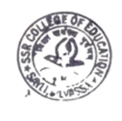
Duration: One academic year / full programme
Meetings: Minimum once a month or as required

Roles and Responsibilities
Role of the Mentor
Maintain individual student profiles
Monitor academic performance and attendance
Conduct regular mentoring sessions
Provide career and professional guidance
Address personal or behavioural concerns
Refer serious issues to counsellors or authorities
Maintain confidentiality
Submit mentoring records to IQAC
Role of the Mentee
Attend mentoring meetings regularly
Share academic and personal concerns honestly
Follow guidance and improvement plans
Maintain discipline and professional conduct
Monitoring and Evaluation
Mentoring records shall be reviewed by the IQAC
Outcomes shall be analysed for quality improvement
Expected Outcomes
Improved academic performance
Enhanced student confidence and motivation
Reduced dropout rate
Better teacher–student relationship
Holistic personality development

