Swargheeya Sanjibhai Rupjibhai Memorial Trust’s
SSR COLLEGE OF EDUCATION
Saily, Silvassa, U.T. of Dadra and Nagar Haveli, Pin-396230
Accredited by NAAC with B+ Grade
(Affiliated to the Savitribai Phule Pune University and Recognized by NCTE)

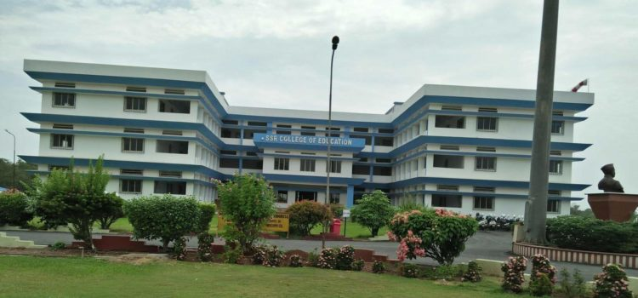

Admissions are open for Academic Year 2026-27

PROSPECTUS- 2026-27

Swargheeya Sanjibhai Rupjibhai Memorial Trust’s
SSR COLLEGE OF EDUCATION
Saily, Silvassa

About SSR Memorial Trust

Swargheeya Sanjibhai Rupjibhai (SSR) Memorial Trust was established in the year 2003 by Honorable founder Chairman late Shri. Mohan S. Delkar with an objective to provide quality and professional higher education in tribal area of Dadra & Nagar Haveli and vicinity area. SSR Memorial Trust has established educational center in the form of four colleges namely SSR college of Arts Commerce & Science, Pharmacy, institute of management & research and SSR college of Education in its campus. All the four colleges are affiliated to Savitribai Phule Pune University, Pune and SSR College of Education is recognized by National Council of Teacher Education (NCTE). At present college runs B.Ed. course (English Medium, Co-Education) with one basic unit of 50 students.
SSR Memorial Trust’s Educational campus is located in Sayli, Silvassa, UT of Dadra & Nagar Haveli with lush green sprawling lawns and gardens. Every college has state of art infrastructure like airy and naturally lighted classrooms, well equipped laboratories, updated and well-furnished libraries, auditorium, sports complex, playground, hostel for boy’s & girl’s, bus shuttle service, temple and canteen facilities providing holistic conducive environment for all round development of students.
About SSR College of Education
SSR College of Education is affiliated to one of the renowned Savitribai Phule Pune University, Pune and it is the only English Medium College of Education in this belt of U.T. of Dadra & Nagar Haveli. The institute is working with a vision for its academic’s excellence, contribution of skillful teachers, creative ability and innovation. The aim is to develop the student teachers with a sense of dedication and commitment towards the teaching profession which further contributes to the society. With this we transform untrained graduate into highly skilled teachers. The institute puts its best efforts to develop professionals who are armed not only with professional knowledge but also with positive attitude, values, skills, sense of responsibility and vision to fulfil organizational goals. SSR College of Education provides dynamic environment to the students with mentor mentee approach, visit to Industry, Botanical gardens, Historical Museum, Celebration of various days, Guest lectures, Online Webinars, Seminar, Workshops to students and teaching & non-teaching staff.

Swargheeya Sanjibhai Rupjibhai Memorial Trust’s
SSR COLLEGE OF EDUCATION
Saily, Silvassa

Shri Anbhinav M. Delkar
Chairman
SSR Memorial Trust
Miss. Divita Delkar
Secretary
SSR Memorial Trust

Director’s Message
It’s my immense pleasure to share a few words as the principal of SSR Memorial Trust’s SSR College of Education, Sayli, Silvassa.
Our college is affiliated to one of the renowned Savitribai Phule Pune University, Pune State of Maharashtra and it is the only English Medium College of Education in this belt of U.T. of Dadra & Nagar Haveli. This institute is working with a vision for its academic excellence, contribution of skillful teachers, creative ability and innovation. The aim is to develop the student teachers with a sense of dedication and commitment towards the teaching profession which further contributes to the society. With this we transform untrained graduates into highly skilled teachers. The institute puts its best efforts to develop professionals who are armed not only with professional knowledge but also with positive attitude, values, skills, sense of responsibility and vision to fulfil organizational goals. SSR College of Education provides dynamic environment to the students with mentor mentee approach, visit to Industry, Botanical gardens, Historical Museum, Celebration of various days, Guest Lectures, Online Webinars, Seminars, Workshop to students and teaching & non-teaching staff throughout the year. Thus, our faculty and student trainees are gloriously stepping towards Quality Teacher Education through sincere and dedicated efforts in teaching, learning and extension activities. They are aware of their role as mentor and facilitator. Our SSR Memorial Trust is always supportive and generous enough for Quality Education.
I, very sincerely hope that all our faculty and our student trainees would achieve grand success in their academic excellence.
With best wishes.
Director
Dr. Meena Prakash Kute

Vision
To develop Teachers who are capable of catering local and global needs in field of education and all-round development of student-teachers to meet challenges of 21st century by pursuing continuous excellence at par of international standards holding local roots in arena of education and research.

Mission
To impart education of global standards by inculcating creative ability and innovation in the students of tribal area in order to achieve academic excellence while maintaining ethical teaching practices.

Swargheeya Sanjibhai Rupjibhai Memorial Trust’s
SSR COLLEGE OF EDUCATION
Saily, Silvassa
Admission Process
Application for MAH-B.Ed. CET and B.Ed. ELCT

Link- www.mahacet.org
Registration for Centralized Admission Process

Link- https://cetcell.mahacet.org/
Appear for MAH-B.Ed. CET and B.Ed. ELCT

Eligibility Criteria
For other than Maharashtra Candidates: - Minimum 55% Marks in graduation for all Categories all Subjects and all Faculties.
For Maharashtra Candidates: - 50% Marks for Open Category and 45% marks for Reserved Class candidates belonging to State of Maharashtra having caste certificate, Caste validity and Non-Creamy layer Certificate if applicable.
Allotment of Students by CET CELL (Round wise Admission)

Swargheeya Sanjibhai Rupjibhai Memorial Trust’s
SSR COLLEGE OF EDUCATION
Saily, Silvassa
College Infrastructure

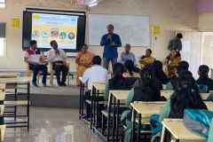
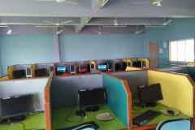

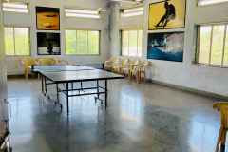
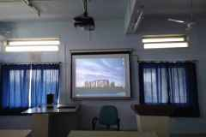

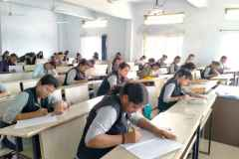
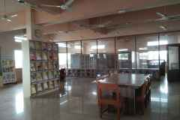

Committees and Cell
- Placement Cell
- Guidance and Counseling Cell
- Grievance Redressal Cell
- Anti-Ragging Cell

Swargheeya Sanjibhai Rupjibhai Memorial Trust’s
SSR COLLEGE OF EDUCATION
Saily, Silvassa

General objectives of the B.Ed. Programme

To enable the student teacher:
- to integrate the study of subject knowledge, human development, pedagogical knowledge and communication skill in student teachers.
- to promote capabilities for inculcating national values and goals as mentioned in the Constitution of India.
- to act as agents of modernization and social change.
- to promote social cohesion, international understanding and protection of human rights and rights of the child.
- to become competent and committed professionals willing to perform the identified tasks.
- to use competencies and skills needed for becoming an effective teacher in a normal setup and in an inclusive setup.
- to understand, develop and apply various evaluation procedures in education.
- to be sensitive student teacher about emerging issues such as environment, population, gender equality, legal literacy, critical understanding of ICT, yoga education, etc.
- to inculcate rational thinking and scientific temper among the students.
10.to develop critical awareness about the social realities among
the students.
11.to use managerial and organizational skills.
12.to enrich himself/herself by actual engagement in the field.
13.to enable him/her to become aware about the day-to-
day problems in the field and develop the capacity to solve
them through research.
14.to develop an understanding of the interdisciplinary
perspectives in education
15.to develop the habit of reflective teaching among the student
teachers.
16.to enhance professional capacities like reading and
reflecting on texts, understanding of self, understanding the
use of drama and art in education, etc.

Swargheeya Sanjibhai Rupjibhai Memorial Trust’s
SSR COLLEGE OF EDUCATION
Saily, Silvassa

Programme Learning Outcomes

After successfully completing the B.Ed. course student teacher will be able to:
- enhance their subject knowledge, human development, pedagogical knowledge and communication skill in student teachers.
- promote the capabilities for inculcating national values and goals as mentioned in the Constitution of India will be promoted.
- act as agents of modernization and social change.
- promote social cohesion, international understanding and protection of human rights and rights of the child.
- become competent and committed professionals willing to perform the identified tasks.
- use competencies and skills needed for becoming an effective teacher in a normal setup and in an inclusive setup.
- understand, develop and apply various evaluation procedures in education.
- be sensitive student teacher about emerging issues such as environment, population, gender equality, legal literacy, critical understanding of ICT, yoga education, etc.
- inculcate rational thinking and scientific temper among the students.
10.develop critical awareness about the social realities among
the students.
11.use managerial and organizational skills.
12.enrich himself/herself by actual engagement in the field.
13.become aware about the day-to-day problems in the
field and develop the capacity to solve them through
research.
14.understand the interdisciplinary perspectives in
education.
15.enhance their professional capacities like reading and
reflecting on texts, understanding of self, etc.
16.understand the use of drama and art in education.


Choice Based Credit System-2025 (Semester Pattern)
Programme Semester I

Course Category | Course Code | Course Title | Credits | Hours | Marks (I + E)
Perspectives of Education – Core Courses | BED101 | Childhood and Growing up | 4 | 60 | 100  (30+ 70)
Perspectives of Education – Core Courses | BED102 | Contemporary Indian Education, Gender and Society | 4 | 60 | 100  (30+ 70)
Specialized Courses- Optional Courses | BED103 | Understanding Disciplines and School Subjects (any two from the given list) | 4  (2+2) | 60 | 100  (30+ 70)
Specialized Courses- Optional Courses | BED104 | Pedagogy of School Subjects (two subjects from the list as in BED103) | 4  (2+2) | 60 | 100  (30+ 70)
Practicing for Constructivist Teaching Learning | BED105 | Teaching Competency- I:  - Micro Teaching, Integration and Simulation Lessons  - Digital Teaching Skills | 2  (1+1) | 30 | 50  (50+0)
Enhancing Professional Capacities | BED106 | - Planning for Teaching and Evaluation  - Reading and Reflecting on Texts | 2  (1+1) | 30 | 50  (50+0)
Enhancing Professional Capacities | BED107 | - Yoga Education  - Health and Wellness Education | 2  (1+1) | 30 | 50  (50+0)
Enhancing Professional Capacities | BED108 | - Understanding of Self  - Portfolio development | 2  (1+1) | 30 | 50  (50+0)
 |  | Total | 24 | 360 | 600
Semester II

Course Category | Course Code | Course Title | Credits | Hours | Marks (I + E)
 | BED201 | Learning and Teaching | 4 | 60 | 100
 |  |  |  |  | (30+ 70)
Perspectives of | BED202 | Assessment and Evaluation for Learning | 4 | 60 | 100
Education – |  |  |  |  | (30+ 70)
Core Courses | BED203 | Indian Knowledge Systems in Education | 4 | 60 | 100
 |  |  |  |  | (30+ 70)
Practicing for Constructivist Teaching Learning | BED204 | Teaching Competency -II:Practice Lessons | 2 | 30 | 50  (50+0)
Practicing for Constructivist Teaching Learning | BED205 | Teaching Competency -III: Introduction to Internship (4 Weeks) | 2 | 30 | 50  (50+0)
 | BED206 | A) Educational Event Management | 2 | 30 | 50
 | BED206 | B) Digital Initiatives for Education | (1+1) | 30 | (50+0)
Enhancing Professional Capacities | BED207 | Application of ICT and Digital Learning | 2 | 30 | 50  (50+0)
Enhancing Professional Capacities | BED208 | - Community Engagement  - Outreach Activities | 2  (1+1) | 30 | 50  (50+0)
 | BED209 | Portfolio and Viva | 2 | 30 | 50
 |  |  |  |  | (0+50)
 |  | Total | 24 | 360 | 600

Swargheeya Sanjibhai Rupjibhai Memorial Trust’s
SSR COLLEGE OF EDUCATION
Saily, Silvassa

Semester III

Course Category | Course Code | Course Title | Credits | Hours | Marks (I + E)
Perspectives of Education – Core Courses | BED301 | Advanced, Innovative and Digital Pedagogy | 4 | 60 | 100  (30+ 70)
Perspectives of Education – Core Courses | BED302 | Quality and Management of School Education | 4 | 60 | 100  (30+ 70)
Specialized Courses-  Optional Courses | BED303 | Understanding disciplines and  Pedagogy of School Subject (Any one subject other than opted under BED103) | 4 | 60 | 100  (30+ 70)
Practicing for Constructivist Teaching Learning | BED304 | Teaching Competency-IV: Practice Lessons | 2 | 30 | 50  (50+0)
Practicing for Constructivist Teaching Learning | BED305 | Teaching Competency-V: Internship (8 Weeks) | 4 | 60 | 100  (100+0)
Enhancing Professional Capacities | BED306 | Educational Research Project | 2 | 30 | 50  (50+0)
Enhancing Professional Capacities | BED307 | - Positive Behaviour Support in Education  - Mentoring in Education | 2  (1+1) | 30 | 50  (50+0)
Enhancing Professional Capacities | BED308 | - Student-teacher Support and Progression: Preparation for Teaching Profession and Entrance Exams  - Portfolio Management | 2  (1+1) | 30 | 50  (50+0)
 |  | Total | 24 | 360 | 600
Semester IV

Course Category | Course Code | Course Title | Credits | Hours | Marks (I + E)
Perspectives of Education – Core Courses | BED401 | Knowledge and Curriculum, Language Across Curriculum | 4 | 60 | 100  (30+ 70)
Perspectives of Education – Core Courses | BED402 | School and Inclusive School | 4 | 60 | 100  (30+ 70)
Specialized Courses-  Optional Courses | BED403 | Elective (Any one from the list) | 4 | 60 | 100  (30+ 70)
Practicing for Constructivist Teaching Learning | BED404 | Teaching Competency VI: Internship (8 weeks) | 4 | 60 | 100  (100+ 0)
Enhancing Professional Capacities | BED405 | Drama and Art in Education | 2 | 30 | 50  (50+0)
Enhancing Professional Capacities | BED406 | Understanding National Education Policy 2020: School Education | 2 | 30 | 50  (50+0)
Enhancing Professional Capacities | BED407 | Open Course | 2 | 30 | 50  (50+0)
Enhancing Professional Capacities | BED408 | Portfolio and Viva | 2 | 30 | 50  (0+50)
Semester Total |  |  | 24 | 360 | 600
Final Total |  |  | 96 | 1440 | 2400

Swargheeya Sanjibhai Rupjibhai Memorial Trust’s
SSR COLLEGE OF EDUCATION
Saily, Silvassa
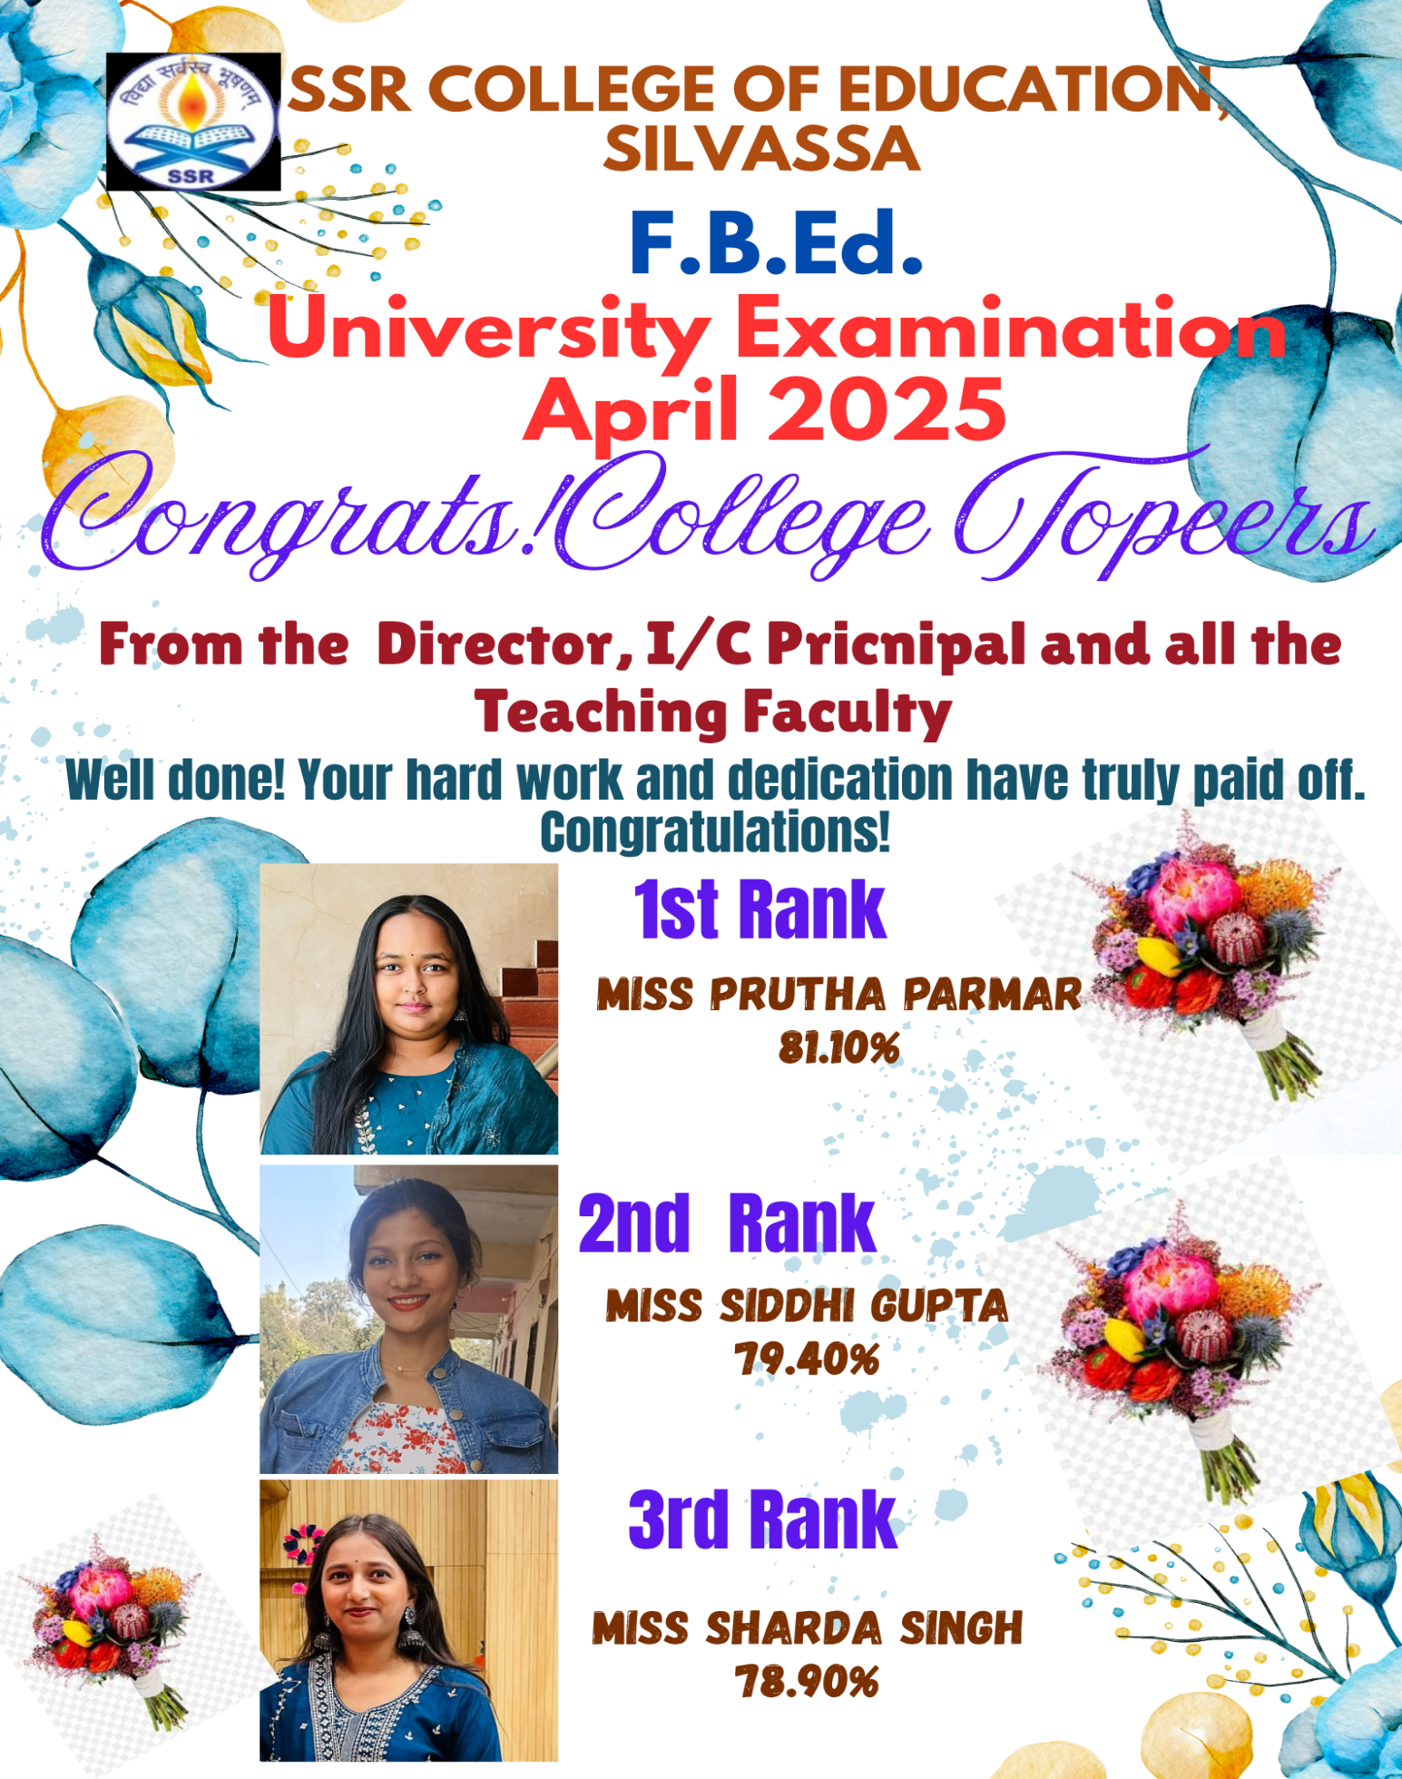
Swargheeya Sanjibhai Rupjibhai Memorial Trust’s
SSR COLLEGE OF EDUCATION
Saily, Silvassa
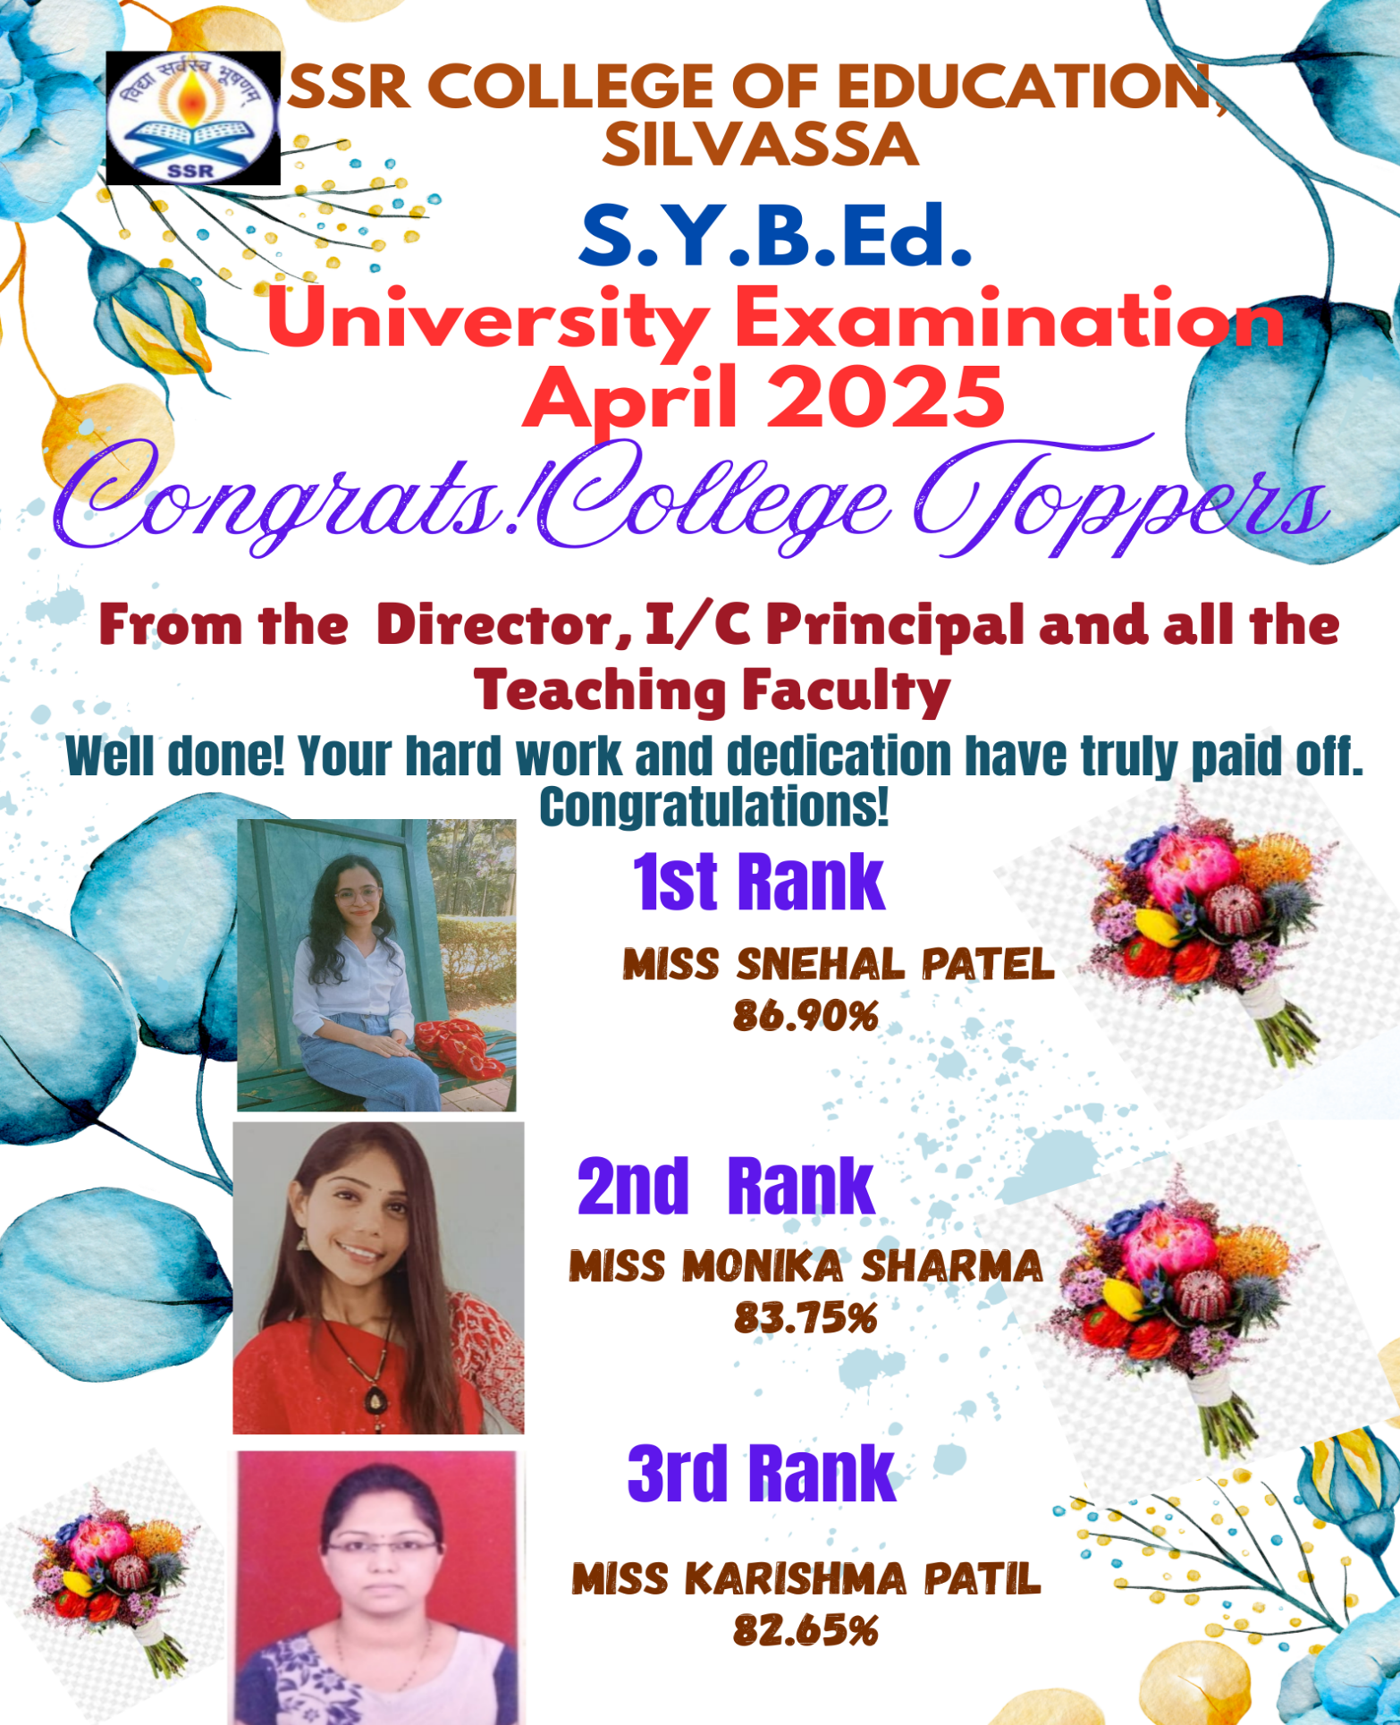

Swargheeya Sanjibhai Rupjibhai Memorial Trust’s
SSR COLLEGE OF EDUCATION
Saily, Silvassa

Our Well Qualified and Committed Faculties
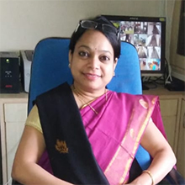
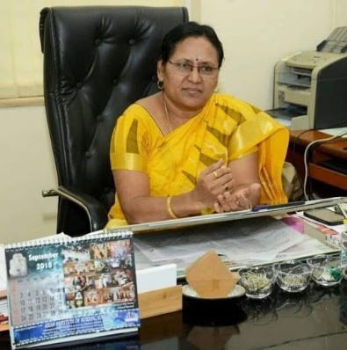

Director In-charge Principal

Dr. Meena Kute Dr. Sarika Patel

M.A., M.Ed. NET, Ph.D. M.Sc., M.Ed., NET, Ph.D.

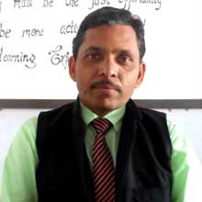
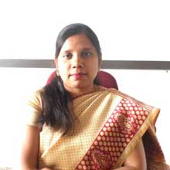


Dr. Vinu Agrawal Mrs. Nirupama Sahu Dr. Bhagirath Pande

Assistant Professor Assistant Professor Assistant Professor

M.A., M.Ed., Ph. D. M.A., M.Ed., Ph.D. M.A., M.Ed., NET, Ph.D.
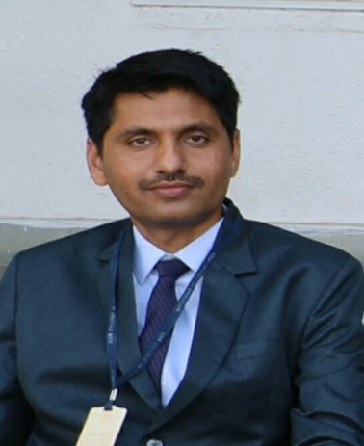
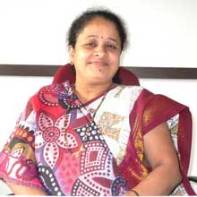
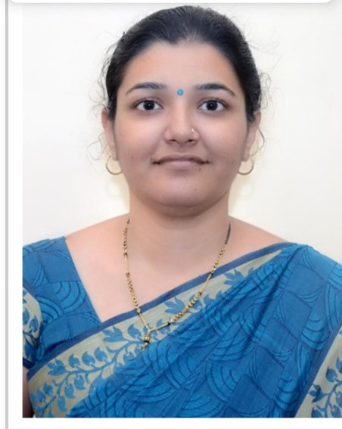

Mr. Nandkishor Bodkhe Mrs.Nilima Kamlu Mrs. Snehal Mahajan

Assistant Professor Assistant Professor Librarian

M.A., M.Ed., NET,SET M.Sc., M.Ed., NET, SET B.A., M.Lib & I.S.c., SE
Swargheeya Sanjibhai Rupjibhai Memorial Trust’s
SSR COLLEGE OF EDUCATION
Saily, Silvassa
Our students’ trainees – Proud of SSR College of Education
Activities

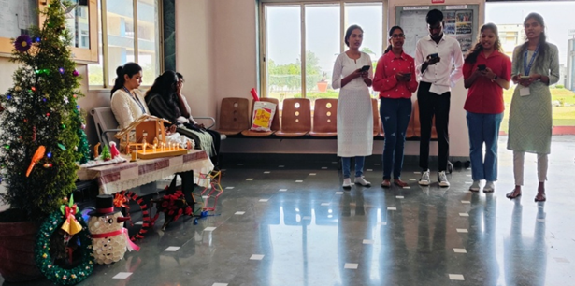
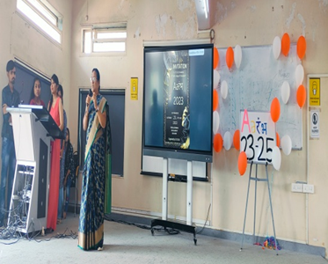
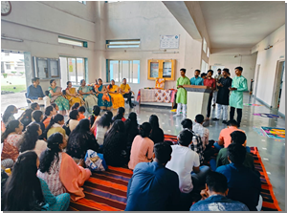
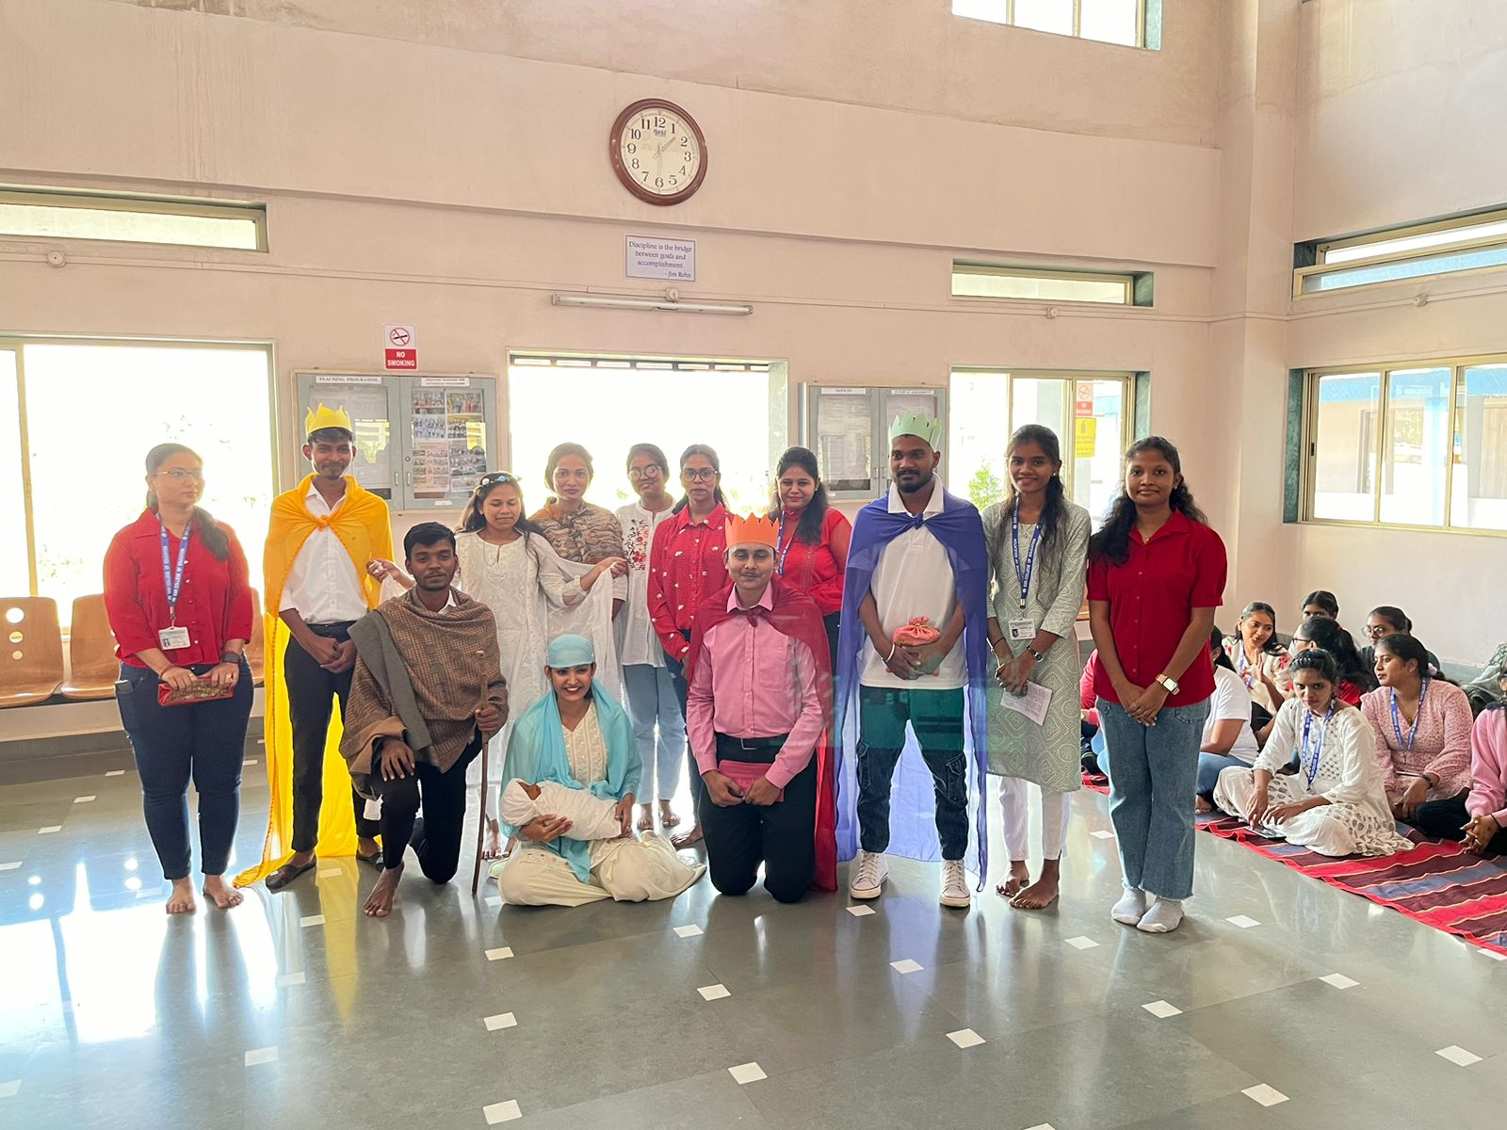
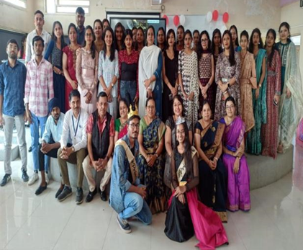
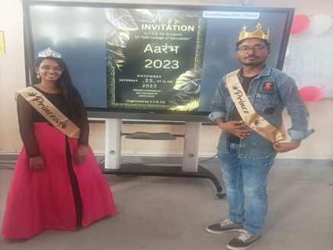
Aarambh 2023
Aarambh 2023
Aarambh 2023
Aarambh 2023
Diwali Celebration 2023
Christmas Celebration 2023
Christmas Celebration 2023

Swargheeya Sanjibhai Rupjibhai Memorial Trust’s
SSR COLLEGE OF EDUCATION
Saily, Silvassa

Well-Maintained Facilities
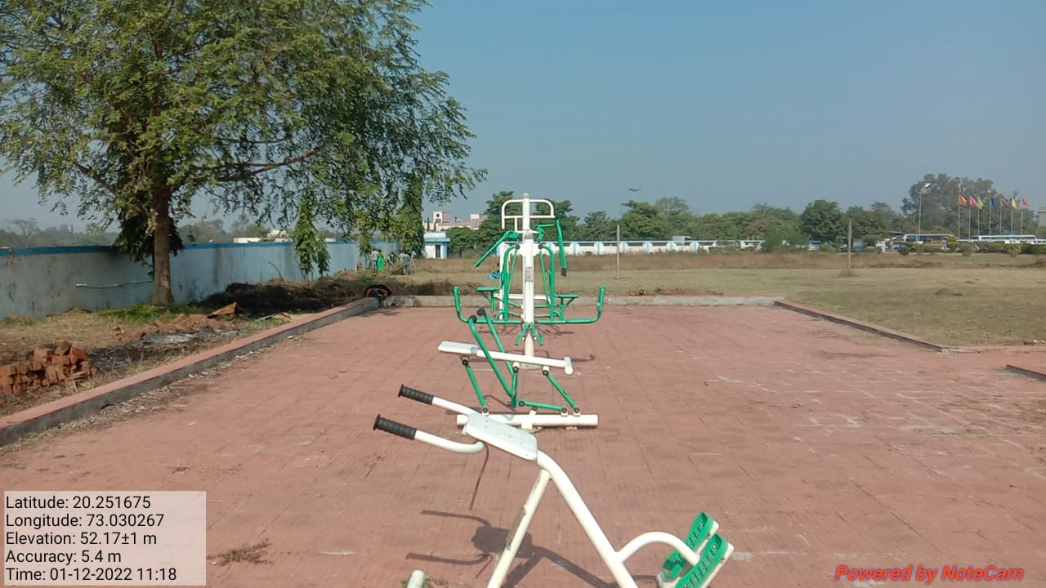
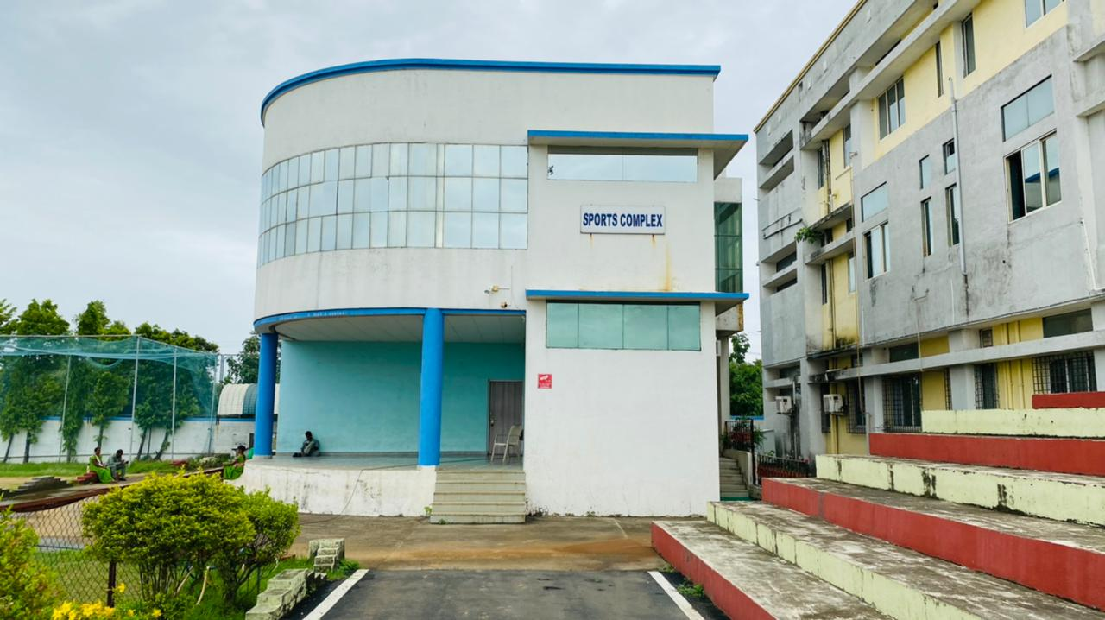
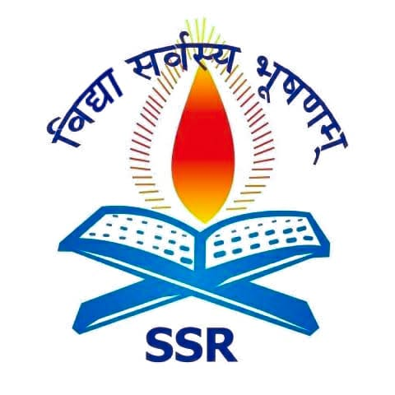
Play Ground
Canteen
Open Gym
Sports Complex

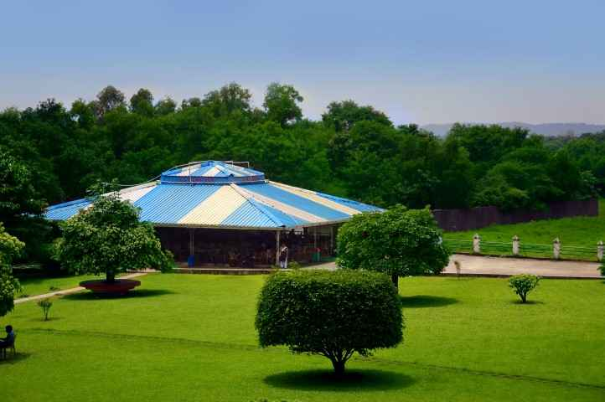
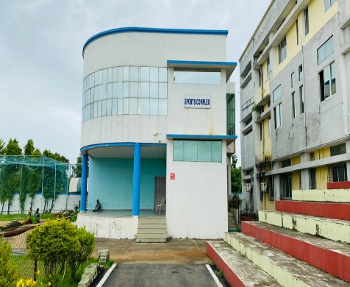
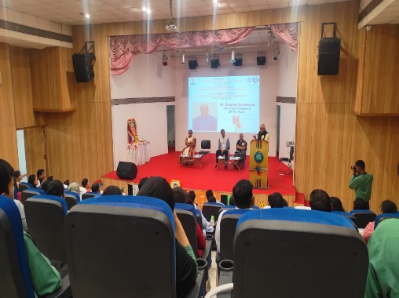

Auditorium Canteen Sports Complex
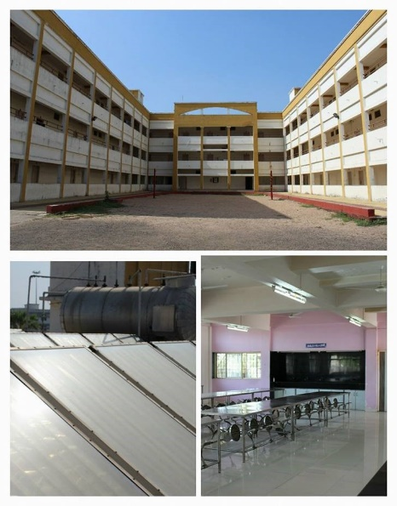
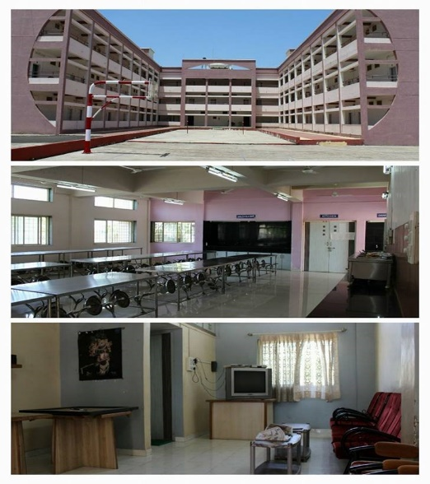
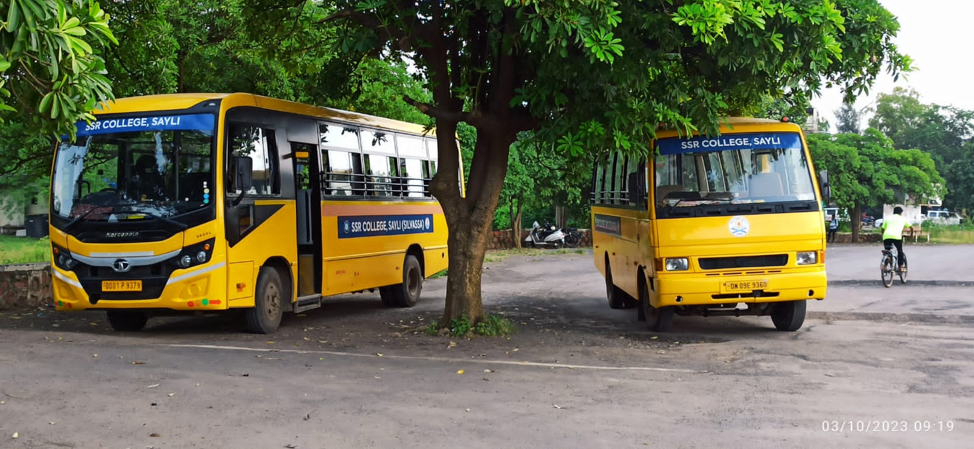

Bus Facility Boys Hostel Girls Hostel
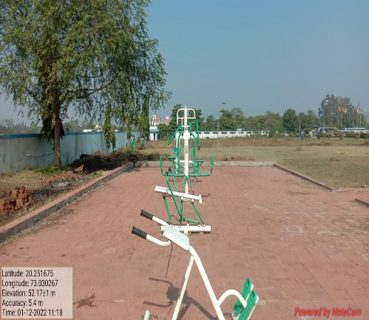
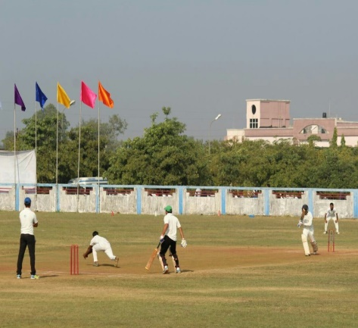
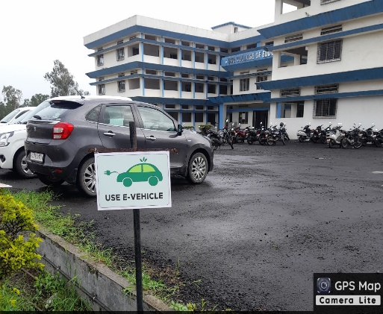

Open Gym Cricket Ground Parking
Swargheeya Sanjibhai Rupjibhai Memorial Trust’s
SSR COLLEGE OF EDUCATION
Saily, Silvassa

National Conference organized by college on ‘NEP 2020: Ensuring Universal Access to Education’

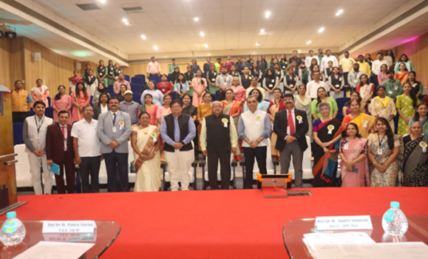
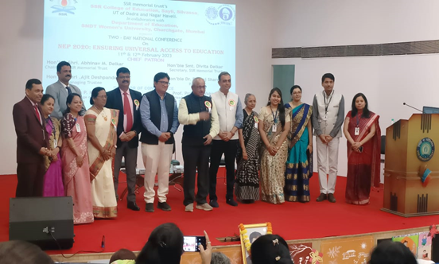

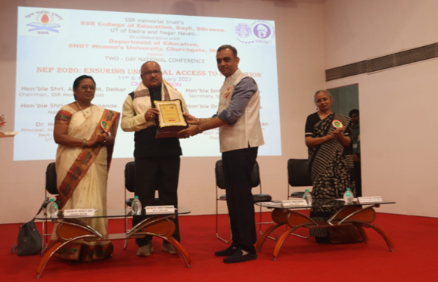
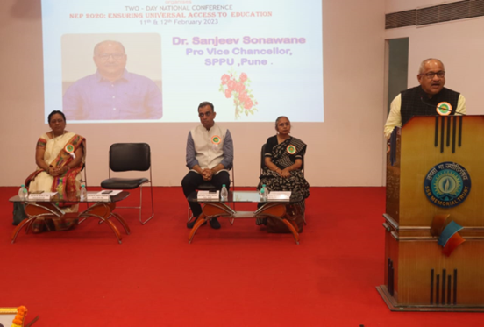



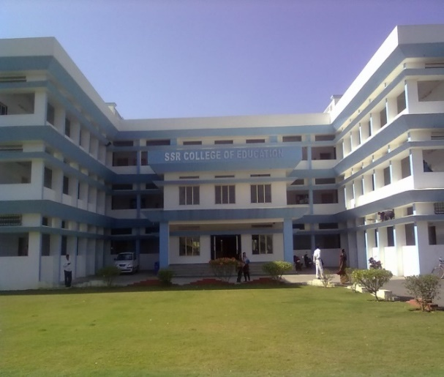
SSR Memorial Trust, a self-financed charitable Trust started with a mission to promote education towards excellence and education for all. SSR College of Education isone of the feather in the SSR Memorial Trust’s cap, operational since 2007. The college is affiliated to SAVITRIBAI PHULE PUNE UNIVERSITY and approved by NCTE, presently running the Two years’ Programme of ‘SSR College of Education’ (B.Ed). The college enjoys the uniqueness of being affiliated to university of repute and it is privileged to find its existence amidst a huge Industrial belt at Dadra & Nagar Haveli.
The University Results, teaching quality, overall personality development of students and great assistance with placement makes the Institute stand tall in this ever-increasing competitive professional world. The college is working with a vision for its academic excellence, research contribution, creative ability and innovation.

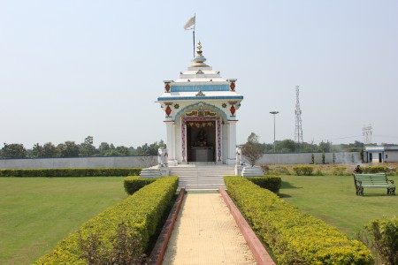

SSR College of Education
Sayli-Silvassa Road, Silvassa – 396230, UT of Dadra & Nagar Haveli Approved by NCTE & Affiliated to Savitribai Phule Pune University, Pune
Phone:, 9081160004

